**EXP NO: 16 Find Last Connected USB on your system NAME : ADHIYAN PERIYAR R P**

**DATE: 18/09/2025 ROLL NO : 231901002**

**Aim :**

Find Last Connected USB on your system (USB Forensics)

**Procedure :**

* USBDeview is a small utility that lists all USB devices that currently connected to

your computer, as well as all USB devices that you previously used.

* For each USB device, extended information is displayed: Device name/description, device type, serial number (for mass storage devices), the date/time that device was added, VendorID, ProductID, and more…
* USBDeview also allows you to uninstall USB devices that you previously used,disconnect USB devices that are currently connected to your computer, as well as to disable and enable USB devices.
* You can also use USBDeview on a remote computer, as long as you log in to that computer with admin user

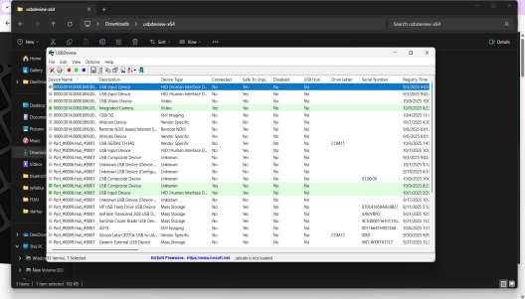

**Result:**

Thus, the forensic tools executed successfully, and the evidence was captured and analyzed accurately